1.0 **Background**

The National Library of Malaysia (Malay: Perpustakaan Negara Malaysia) (PNM) is a library established under the National Library Act 1972 in Kuala Lumpur, Malaysia.

The National Library is responsible for providing a collection of knowledge at national level for the present and future generations. In its effort to strengthen the library's collection, the National Library continues to play an active role in its acquisition of library materials through enforcement of the Deposit of Library Material Act 1986, acquisition, gift and exchange.

The pride of the National Library's collection is the Malaysiana Collection. It comprises library materials published in Malaysia and overseas whose whole or larger part of the content is related to the publications date or the language used.

2.0 **Product and service**

2.1 Acquisition

-When the library purchases a book, it records the book that it wants to buy in the system, and then sends it to the publishers to get the quotation, and then place the order.

2.2 Cataloging

-After the book is buy in, the next step is cataloging - bar code (barcode), classification (this is the most tiring work in the entire cataloging process, requires a professional librarian), printing and pasting the book number (Shelfmark) until place on the shelf, this process It is called cataloging.

2.3 Investigation

-Online public access catalog (OPAC)

-The library must have an retrieval system (OPAC) for readers to find books or search for information.

2.4 Statistical Reports

-The library needs some reports, such as: borrowing rates, most popular books, reader types, etc.

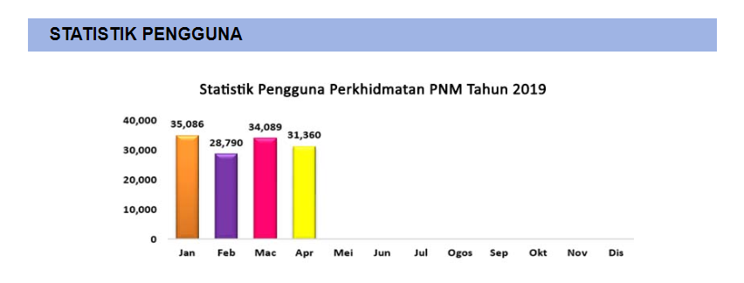

2.5 Library Card

-All readers should hold a PNM (Perpustakaan Negara Malaysia) ID card through the library security gate and access to library services and borrow books from the library. The holder is the only valid user of the PNM ID card. All Malaysians can borrow books from the library using PNM ID cards.

2.6 e-Book

-E-book lending or e-lending is a practice in which access to already-purchased downloads or online reads of e-books is made available on a time-limited basis to others. Libraries have always been able to acquire and lend physical books Without requiring any special permission from publishers.

3.0 **Business Operation**

3.1 Customers

3.1.1 Students

- Our major customers are the students. This is because National Library Malaysia will provide some of the latest books in any subjects here. The purposes of students borrowing books in our library may different. Some of them borrow books for their examination, some of them borrow books for knowledge.

3.1.2 Teachers

- Teachers will borrow some books for referring of their subjects. It is to help their students in learning those subjects.

3.1.3 Books lover / Intellectuals

- The National Library of Malaysia provides every kind of books for readers. It is a must visit library for books lover and intellectuals.

3.1.4 Authors / Writers

- As a authors and writers, they like to read a lot of books in order to get inspiration for writing their own books. National Library Malaysia will provide the books and the best environment for them.

3.2 Collaboration With Other Libraries

3.2.1 In State

- PERPUN

- SCOM

- VTLS User Group Malaysia

- CDS/ISIS Library

3.2.2 Foreign Country

- NLG-SEA

- CONSAL

- CDNLAO

3.2.3 International

- IFLA

- APINESS (UNESCO)

- ASTINFO (UNESCO)

- Malaysia International Library Center

3.3 Visitorship of National Library Malaysia (NLM)

3.3.1 Visitorship of NLM

- The number of physical visitors to NLM for the year 2017 stands at 369,610 visitors showing decrease of 14,885 (4%) visitors compared to the year 2016 where 384,495 visitors visited NLM. However, the number of online visitors for the year 2017 increase from 261,996 to 297,234.

3.3.2 International Visitor to NLM

- For the year 2017, NLM received a total of 334 international visitors from 49 countries. Among the purpose of these visits are to establish networking, benchmarking on library services, digitization of library resources and resource sharing through gift and exchange of publications.

4.0 Organizational Structure



The structure chart demonstrates the organizational structure of The National Library of Malaysia.

4.1 Functional Area

4.1.1 Library Administration

**Handles interior and outside managerial issues**

Library administration controls everything administrative matters for the Libraries, giving administrative initiative, resource management, development, and so on. Library services and programs were all organized by library administration. Other than that, library administration controls over the budget and finance, administrative reports and other administrative needs.

4.1.2 Collection Services

**Getting, preserving, describing library materials**

Collection services is capable for getting, preserving, and describing library materials to teach and research the needs of the customers that comes to the library. Furthermore, the collection services provide the customers to access the collections of the library. For examples, journals, books, e-journals, databases and so on.

4.1.3 Information Technology Department

**Controls infrastructure and many technology services of the library**

Information technology department manages library infrastructure, technical support service for the facilities of the library, application development, and so on. Information technology department also provides technical tools like computer and printer for customers to use.

4.1.4 Access Service Department

**Providing assistance in finding, borrowing, returning and requesting the library materials for customers**

Library materials are found, borrowed, returned, and requested at the circulation desk in access service department. Access service department provides shelf maintenance, document delivery, study rooms, locker and lost and found service.

4.1.5 Development Department

**Providing maintenance and advancement for the library systems**

Development department conduct research program includes library’s facilities, equipment, designs, books, and so on. Besides that, development department checks and controls the the overall library’s quality to ensure the longevity of the library.